Lunch SAP logon and select Q4T
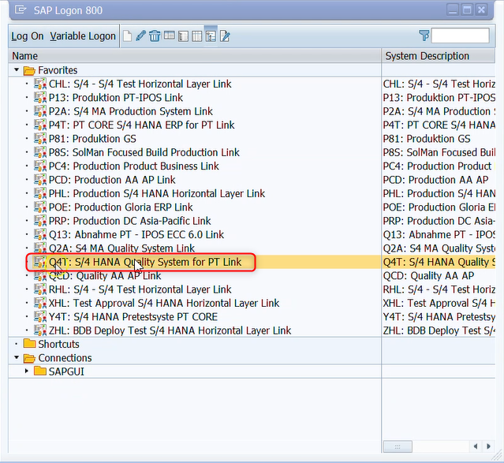

Tcode: enter ‘VA01’ and hit ‘Enter’
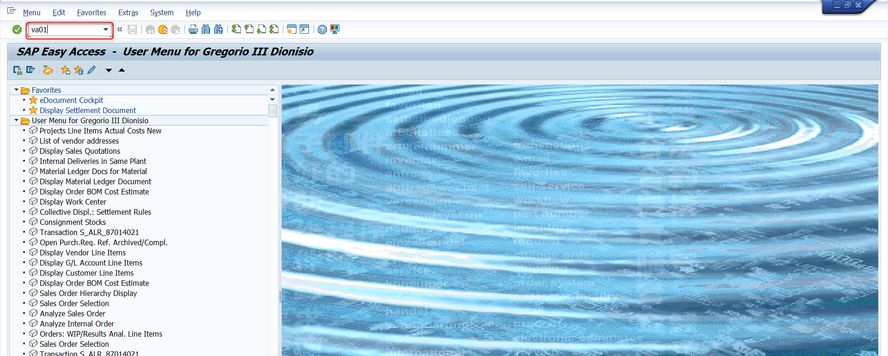

Enter the following information for Sales Order creation.
1. Order type: key-in 'YCC1' and hit 'Tab'
2. Organizational Data
3.1. Sales Organzation: key-in 'IDP1' and hit 'Tab'
3.2. Distribution Channel: key-in '2B' and hit 'Tab'
3.1. Division: key-in '01' and hit 'Tab'
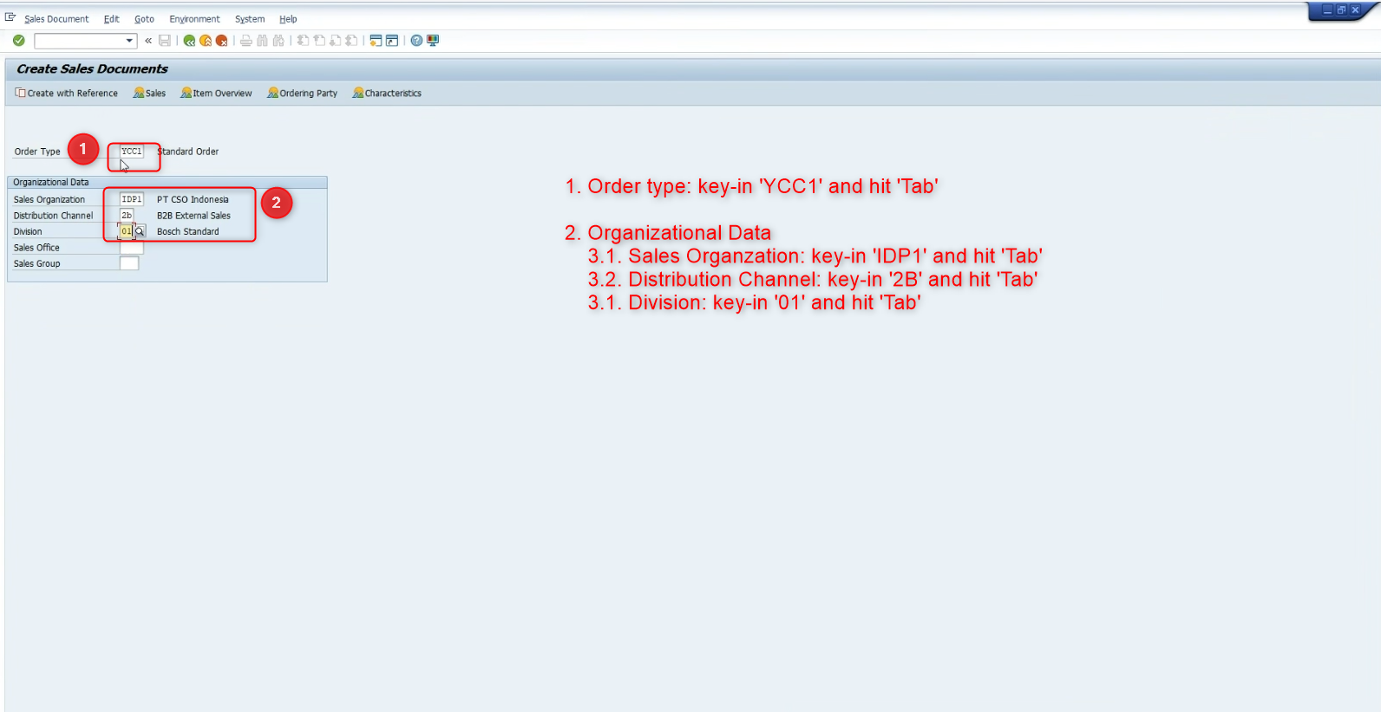
1. Sold-to, Ship-to customer
1.1. Sold-to-Party: Key-in '88100322 then hit 'Tab'
1.2. Ship-to-Party: Key-in '88100322 then hit 'Tab'
All items - sample data
2. Material: Enter 2.608.621.840 then hit 'Tab'
3. Order QUantity: 1 then hit 'Tab'
4. Hit 'Display Header Details'
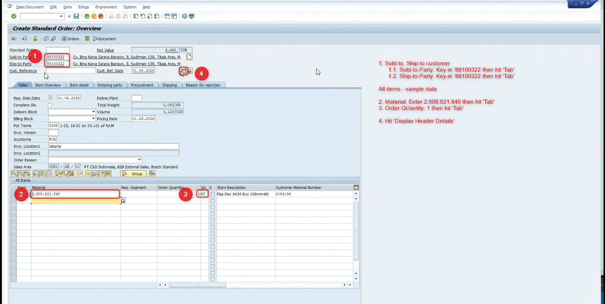

- Goto ‘Order Data’ tab
- Customer reference: Key in ‘Test 2.0’ and hit ‘Tab’
- Purchase Order type: Select ‘TELE’ and hit ‘Tab’
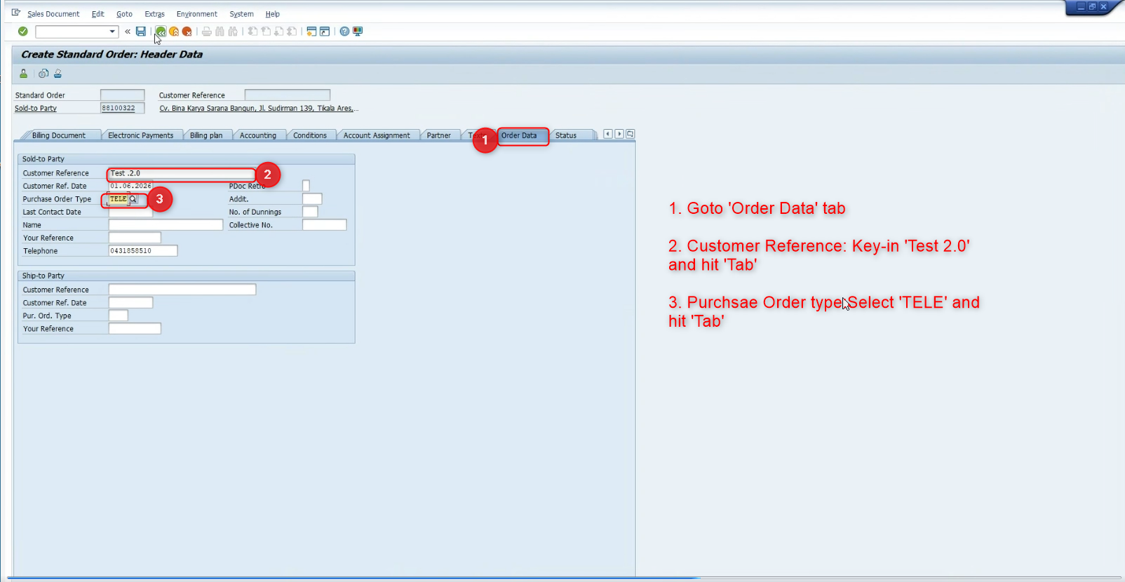
1. Go to 'Shipping' Tab
2. Route: Key-in '41DB1' the hit 'Tab'
3. Click Save to create the Sales order
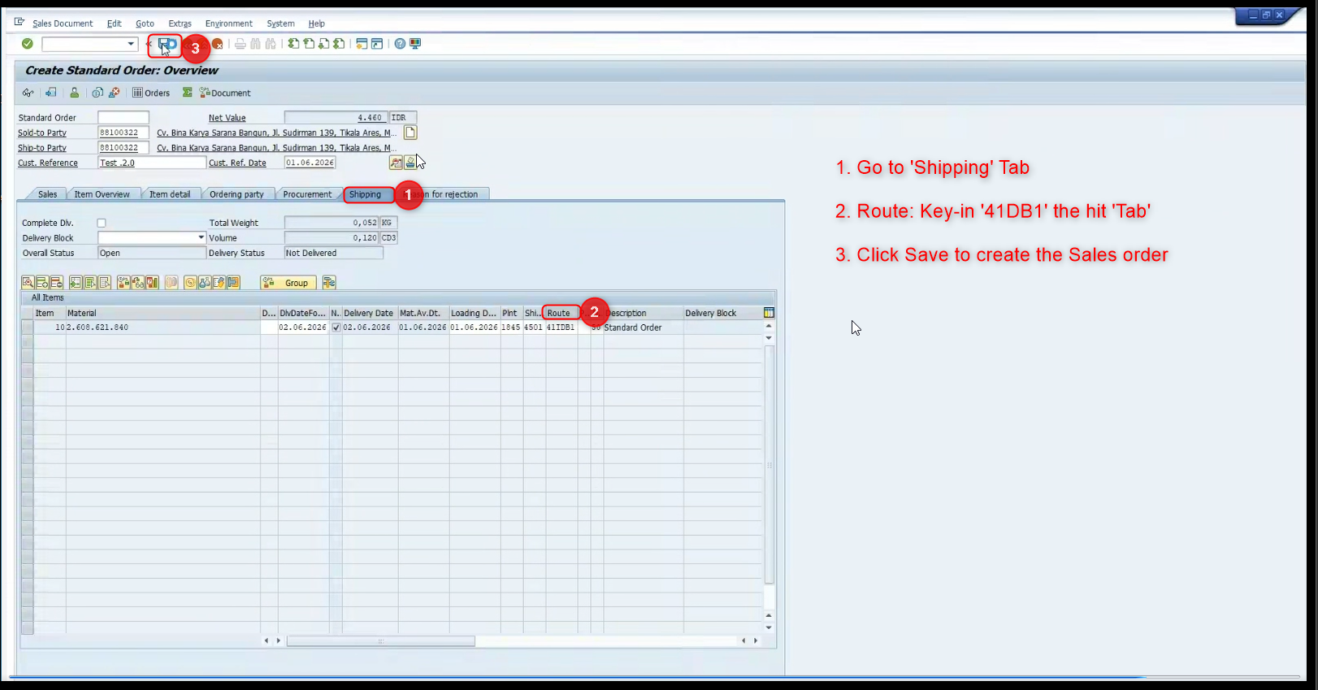
- Sales Order number will be generated after clicking the ‘Save’ button.
- Check if the Sales Order number is created.
